Task 1: Write a python code for reading the content of a URL  
using

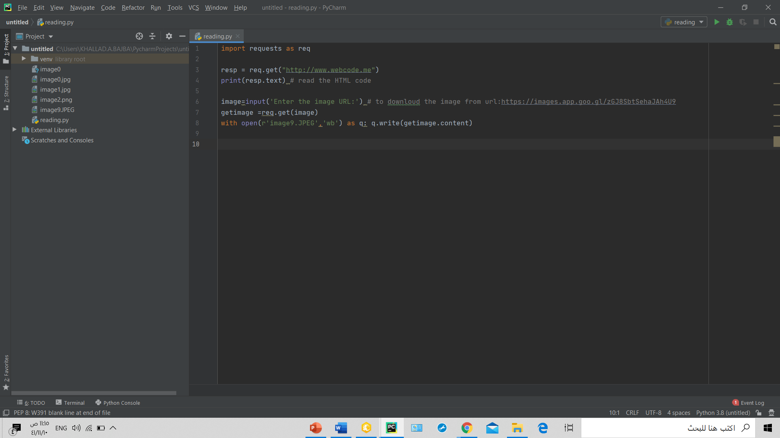Code:

Output:

